4x10GBASE-LR/W
QSFP+ Parallel Single Mode（PSM）Module 10km
GQM-SPO400-LR4CB
Features
◻
◻
◻
◻
◻
◻
◻
◻
◻
◻
◻
◻
◻
Full duplex 4 channel 1310nm parallel module
SFF-8436 QSFP+ compliant
Hot pluggable electrical interface
Differential AC-coupled high speed data interface
4 channels 1310nm DFB laser
4 channels PIN photo detector array
Maximum link length of 10km on G652
Single male MPO(APC 8-degree) connector receptacle
Maximum power consumption 2.5W
Housing isolated from connector ground
Operating case temperature 0°C to +70°C
3.3V power supply voltage
RoHS 6 compliant
Applications
◻
◻
◻
◻
Infiniband Connectivity SDR/DDR/QDR
10GBASE-LR/W 10G Ethernet
2/4/8 Gbps Fiber Channel
Data Centers and Storage Arrays
Description
QSFP PSM LR4 are a high performance, low power consumption, long reach
interconnect solution supporting 40G Ethernet, fiber channel and PCIe. It is compliant with the
QSFP MSA and IEEE 802.3ae 10GBASE-LR/LW3. QSFP PSM LR4 is an assembly of 4
full-duplex lanes, where each lane is capable of transmitting data at rates up to 10.3125Gb/s,
providing an aggregated rate of 40Gb/s.
Page 1 of 14
Aug 19 / 2016 V1
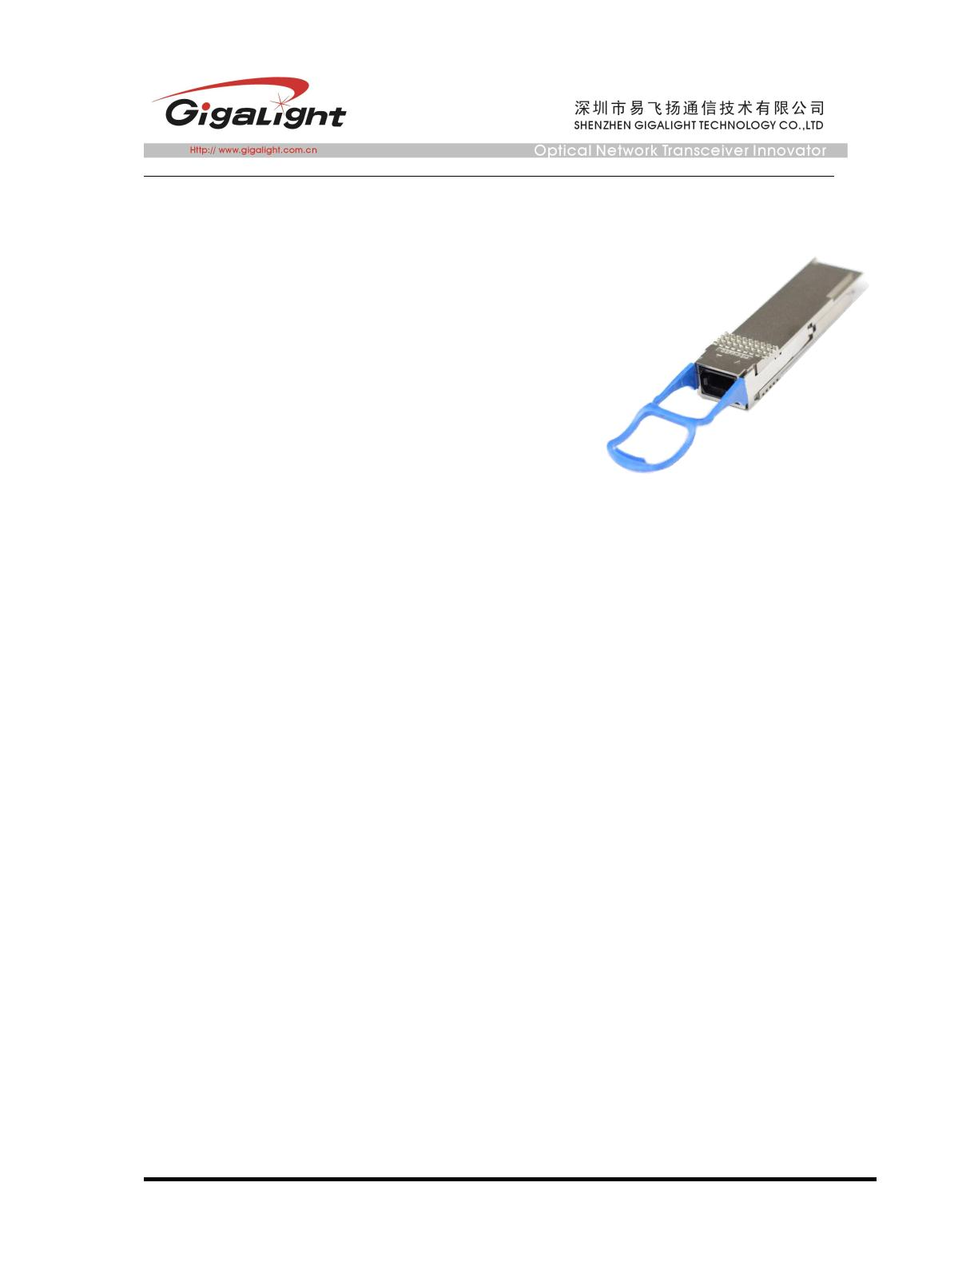

Figure1. Module Block Diagram
QSFP PSM LR4 is one kind of parallel transceiver. DFB and PIN array package is key
technique, through I2C system can contact with module.
Absolute Maximum Ratings
Parameter
Supply Voltage
Symbol
Vcc
Min
-0.3
-0.3
-20
0
Max
3.6
Unit
V
Input Voltage
Vin
Vcc+0.3
85
V
Storage Temperature
Case Operating Temperature
Humidity(non-condensing)
Tst
ºC
ºC
%
Top
70
Rh
5
95
Recommended Operating Conditions
Parameter
Supply Voltage
Symbol
Vcc
Tca
Min
3.13
0
Typical
Max
Unit
3.3
3.47
70
V
ºC
Operating Case temperature
Data Rate Per Lane
Humidity
fd
10.3125
85
Gbps
%
Rh
5
Power Dissipation
Link Distance with G652
Pm
3.5
W
Rb
D
10
km
Page 2 of 14
Aug 19 / 2016 V1
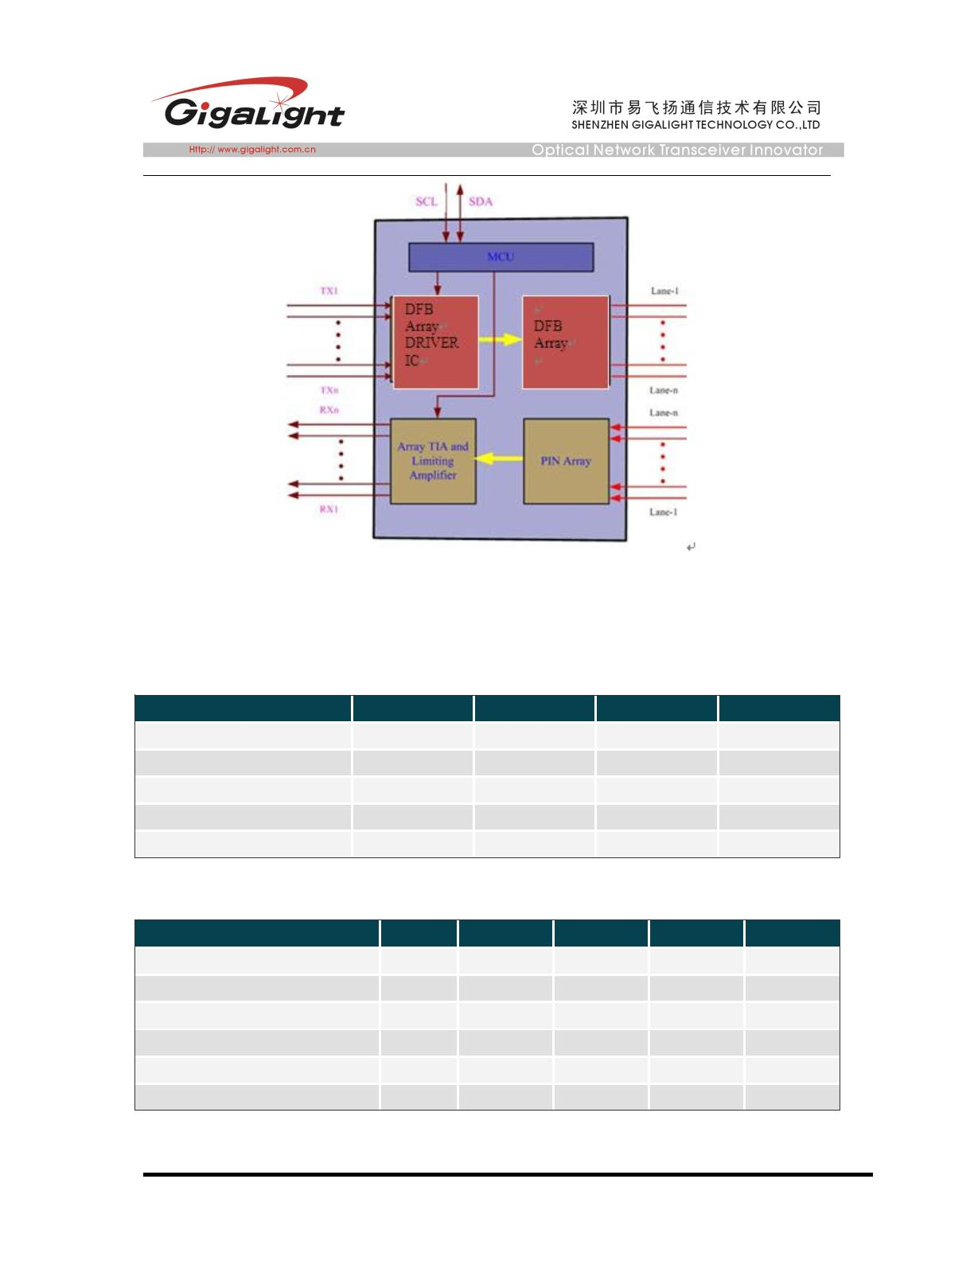

Specifications
Symbo
Parameter
Min
90
Typical
100
Max
110
Unit
ohm
ohm
Differential input impedance
Differential Output impedance
Zin
Zout
90
100
110
Differential input voltage amplitude
Differential output voltage amplitude
ΔVin
350
425
1200
1600
mVp-p
ΔVout
mVp-p
ps
Skew
Sw
BR
300
E-12
VCC
0.8
Bit Error Rate
Input Logic Level High
Input Logic Level Low
Output Logic Level High
Output Logic Level Low
VIH
VIL
2.0
V
V
V
V
0
VCC-0.5
0
VOH
VOL
VCC
0.4
Note：
1.
2.
BER=10^-12; PRBS 2^31-1@10.3125Gbps.
Differential input voltage amplitude is compliant with theIEEE802.3 Annex 86A and
SFF8436,and it is measured at TP1 .
3.
Differential output voltage amplitude is compliant with theIEEE802.3 Annex 86A and
SFF8436,and it is measured at TP4 .
Optical Characteristics
Parameter
Symbol
Min
Transmitter
1290
Typical
Max
Unit
Notes
Centre Wavelength
SMSR
λc
1310
-
1330
nm
dB
-
-
σ
30
Transmit OMA per Lane
Average launch power, each lane
TxOMA
Pout
-5.2
3.0
0.5
dBm
dBm
-8.2
-
-
-
-
Difference in launch power
between any two lanes (OMA)
Ptx,diff
6.5
dB
Extinction Ratio
ER
3.5
-
dB
dB
-
-
Transmitter and dispersion
penalty (TDP), each lane
TDP
2.6
Average launch power of OFF
transmitter, each lane
Poff
RLT
RT
-30
12
dBm
dB
-
Optical Return Loss Tolerance
(max)
Transmitter Reflectance
-12
dB
Eye Mask coordinates:
X1, X2, X3, Y1, Y2, Y3
SPECIFICATION VALUES
0.25, 0.4, 0.45, 0.25, 0.28, 0.4
Hit Ratio
= 5x10-5
Page 3 of 14
Aug 19 / 2016 V1
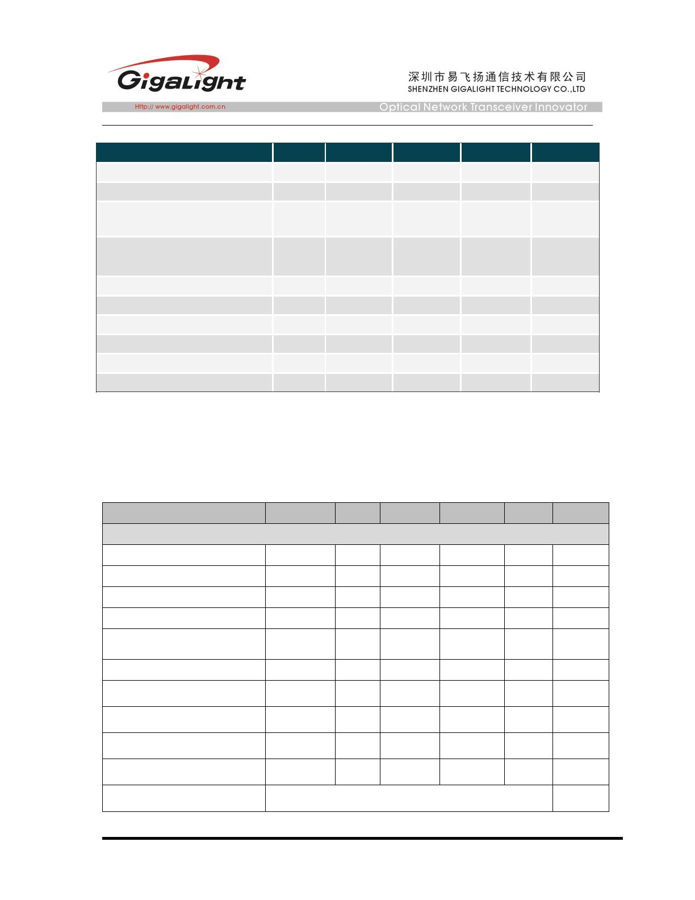

Receiver
Centre Wavelength
λc
1290
1310
1330
-10.3
nm
-
Stressed receiver sensitivity in
OMA, each lane
SEN
dBm
1
Receiver sensitivity in OMA,
each lane(PRBS 2^31-1 and
BER=10^-12)
-12.6
0.5
dBm
2
-
Maximum Average power at
receiver input, each lane
dBm
dB
Difference in Receive Power
between any Two Lanes(OMA)
Prx,diff
7.5
-26
Receiver Reflectance
LOS Assert
RR
dB
dBm
dBm
dB
-
-
-
-
LOSA
LOSD
LOSH
-30
0.5
LOS De-Assert
LOS Hysteresis
-14
Note：
1． Measured with conformance test signal at TP3 for BER = 10e-12
2． 10GBASE-LR spec .
Pin Descriptions
Pin
1
Logic
Symbol
GND
Name/Description
Ref.
Module Ground
1
2
CML-I
CML-I
Tx2-
Transmitter inverted data input
Transmitter non-inverted data input
Module Ground
3
Tx2+
4
GND
1
5
CML-I
CML-I
Tx4-
Transmitter inverted data input
Transmitter non-inverted data input
Module Ground
6
Tx4+
7
GND
1
2
2
8
LVTTL-I
LVTTL-I
MODSEIL
ResetL
VCCRx
SCL
Module Select
9
Module Reset
10
11
12
13
14
15
16
17
+3.3v Receiver Power Supply
2-wire Serial interface clock
2-wire Serial interface data
Module Ground
LVCMOS-I
2
2
1
LVCMOS-I/O
SDA
GND
CML-O
CML-O
RX3+
RX3-
Receiver non-inverted data output
Receiver inverted data output
Module Ground
GND
1
CML-O
RX1+
Receiver non-inverted data output
Page 4 of 14
Aug 19 / 2016 V1
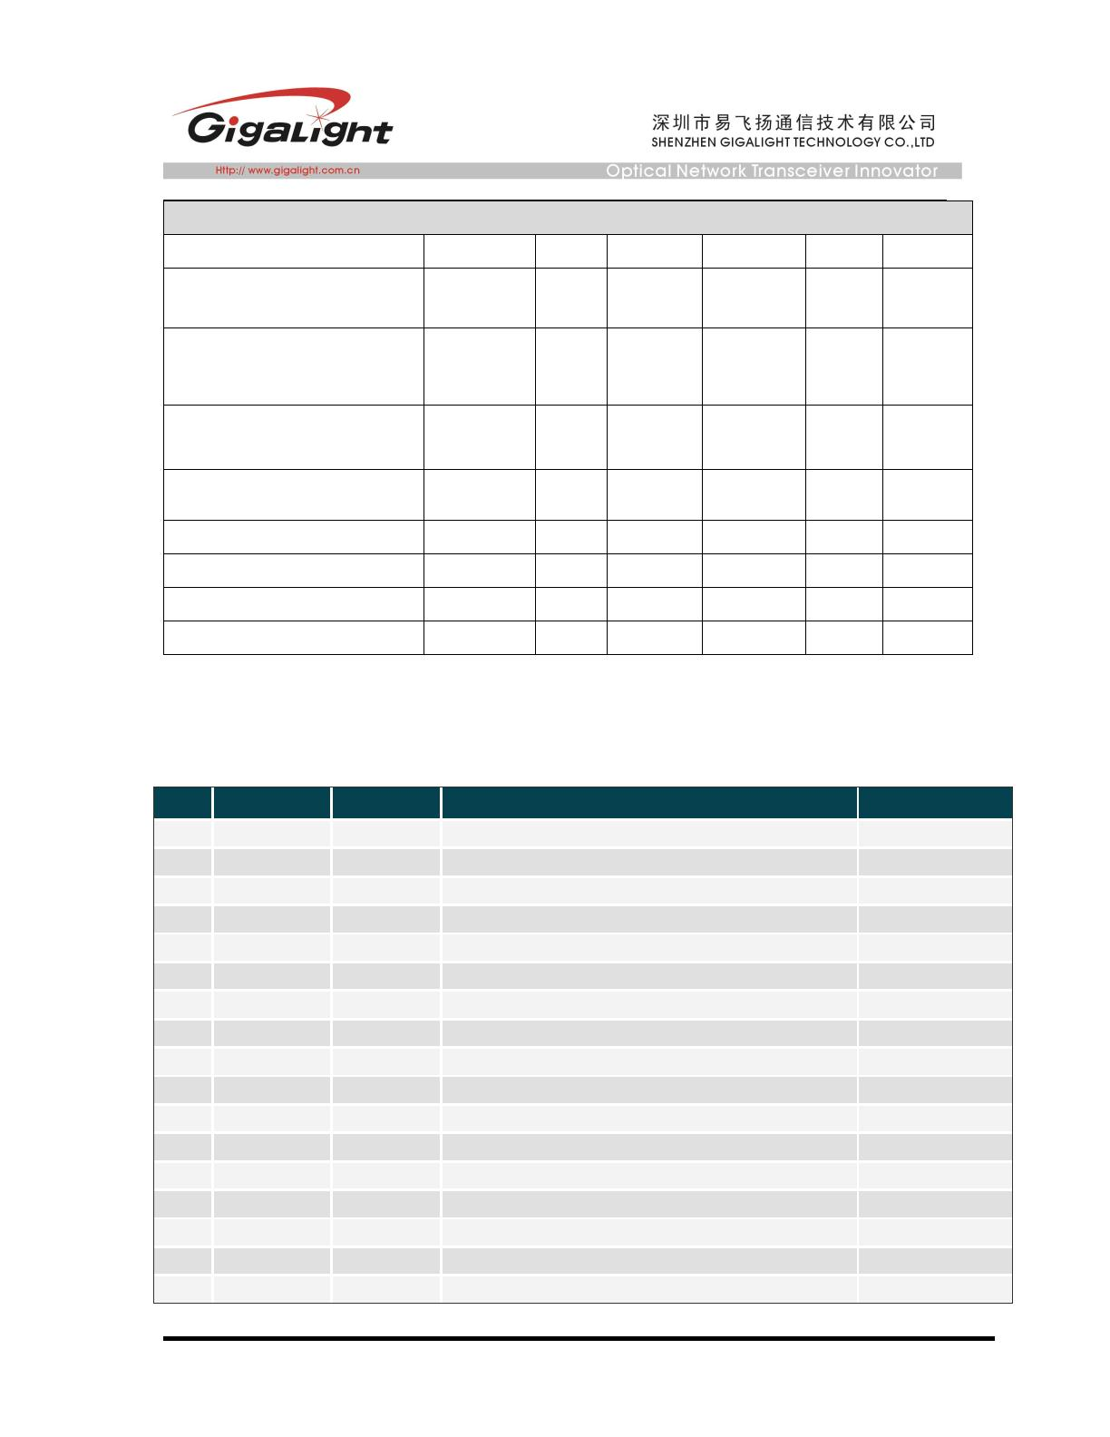

18
19
20
21
22
23
24
25
26
27
28
29
30
31
32
33
34
35
36
37
38
CML-O
RX1-
GND
Receiver inverted data output
Module Ground
1
1
GND
Module Ground
CML-O
CML-O
RX2-
RX2+
GND
Receiver inverted data output
Receiver non-inverted data output
Module Ground
1
CML-O
CML-O
RX4-
RX4+
GND
Receiver inverted data output
Receiver non-inverted data output
Module Ground
1
2
LVTTL-O
LVTTL-O
ModPrsL
IntL
Module Present, internal pulled down to GND
Interrupt output, should be pulled up on host board
+3.3v Transmitter Power Supply
+3.3v Power Supply
VCCTx
VCC1
LPMode
GND
LVTTL-I
Low Power Mode
2
1
Module Ground
CML-I
CML-I
Tx3+
Transmitter non-inverted data input
Transmitter inverted data input
Module Ground
Tx3-
GND
1
1
CML-I
CML-I
Tx1+
Transmitter non-inverted data input
Transmitter inverted data input
Module Ground
Tx1-
GND
Notes:
1. Module circuit ground is isolated from module chassis ground within the module.
2. Open collector; should be pulled up with 4.7k – 10k ohms on host board to a voltage between 3.15V and
3.6V.
Page 5 of 14
Aug 19 / 2016 V1
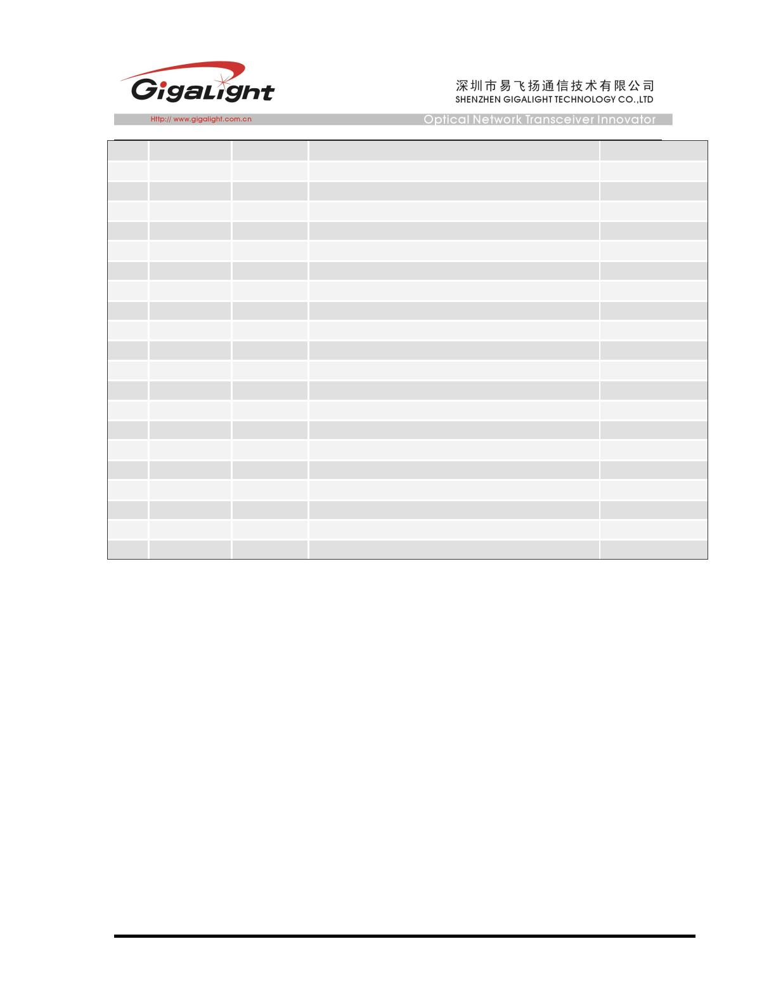

Figure2. Electrical Pin-out Details
ModSelL Pin
The ModSelL is an input pin. When held low by the host, the module responds to 2-wire serial
communication
commands. The ModSelL allows the use of multiple QSFP modules on a single 2-wire
interface bus. When
the ModSelL is “High”, the module will not respond to any 2-wire interface communication
from the host.
ModSelL has an internal pull-up in the module.
ResetL Pin
Reset. LPMode_Reset has an internal pull-up in the module. A low level on the ResetL pin for
longer than the
minimum pulse length (t_Reset_init) initiates a complete module reset, returning all user
module settings to
their default state. Module Reset Assert Time (t_init) starts on the rising edge after the low
level on the
ResetL pin is released. During the execution of a reset (t_init) the host shall disregard all
status bits until the
module indicates a completion of the reset interrupt. The module indicates this by posting an
IntL signal with
the Data_Not_Ready bit negated. Note that on power up (including hot insertion) the module
will post this
completion of reset interrupt without requiring a reset.
LPMode Pin
Gigalight QSFP PSM LR4 operate in the low power mode (less than 1.5 W power
consumption)
This pin active high will decrease power consumption to less than 1W.
ModPrsL Pin
ModPrsL is pulled up to Vcc on the host board and grounded in the module. The ModPrsL is
Page 6 of 14
Aug 19 / 2016 V1
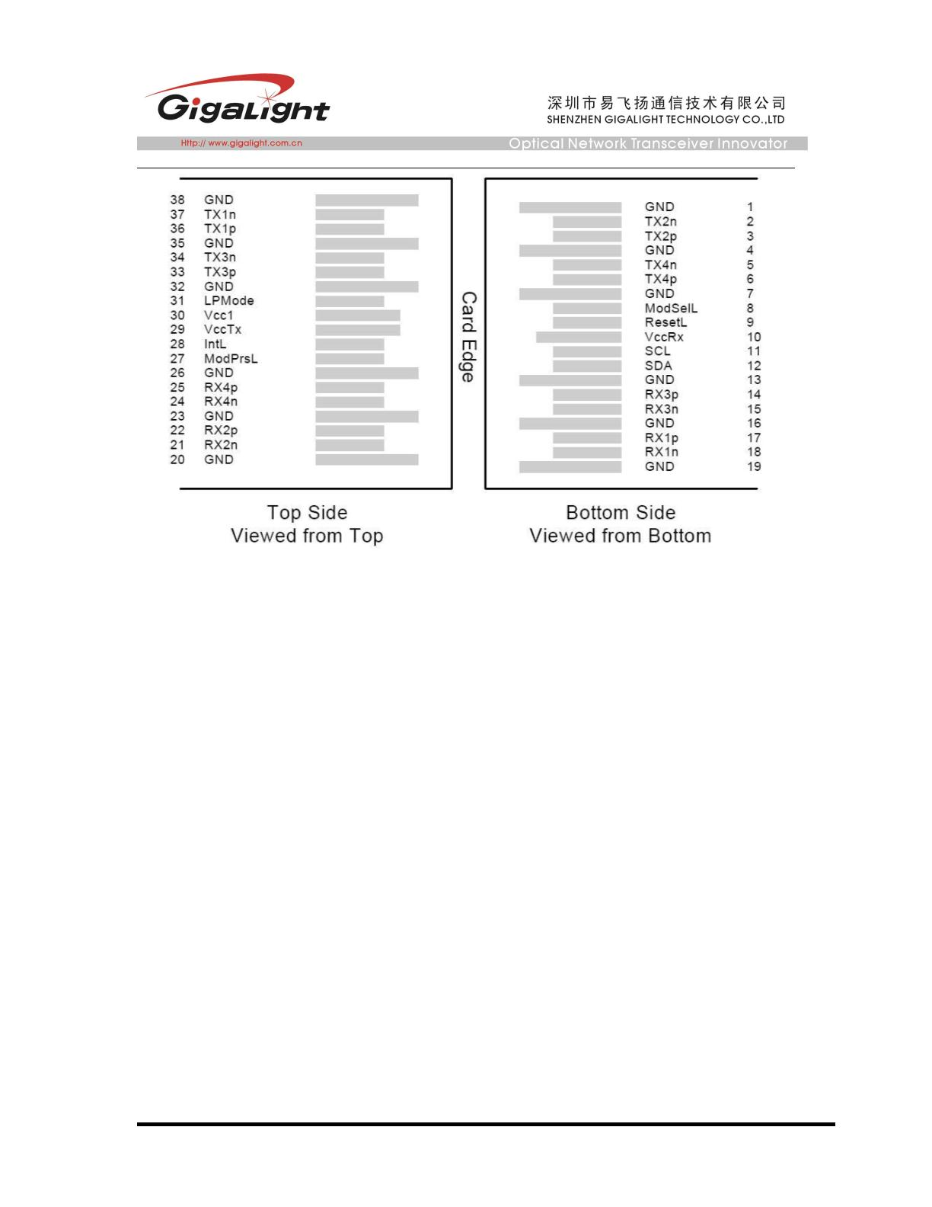

asserted “Low”
when the module is inserted and deasserted “High” when the module is physically absent
from the host connector.
IntL Pin
IntL is an output pin. When “Low”, it indicates a possible module operational fault or a status
critical to the
host system. The host identifies the source of the interrupt by using the 2-wire serial interface.
The IntL pin is
an open collector output and must be pulled up to Vcc on the host board.
Power Supply Filtering
The host board should use the power supply filtering shown in Figure3.
Figure3. Host Board Power Supply Filtering
Page 7 of 14
Aug 19 / 2016 V1
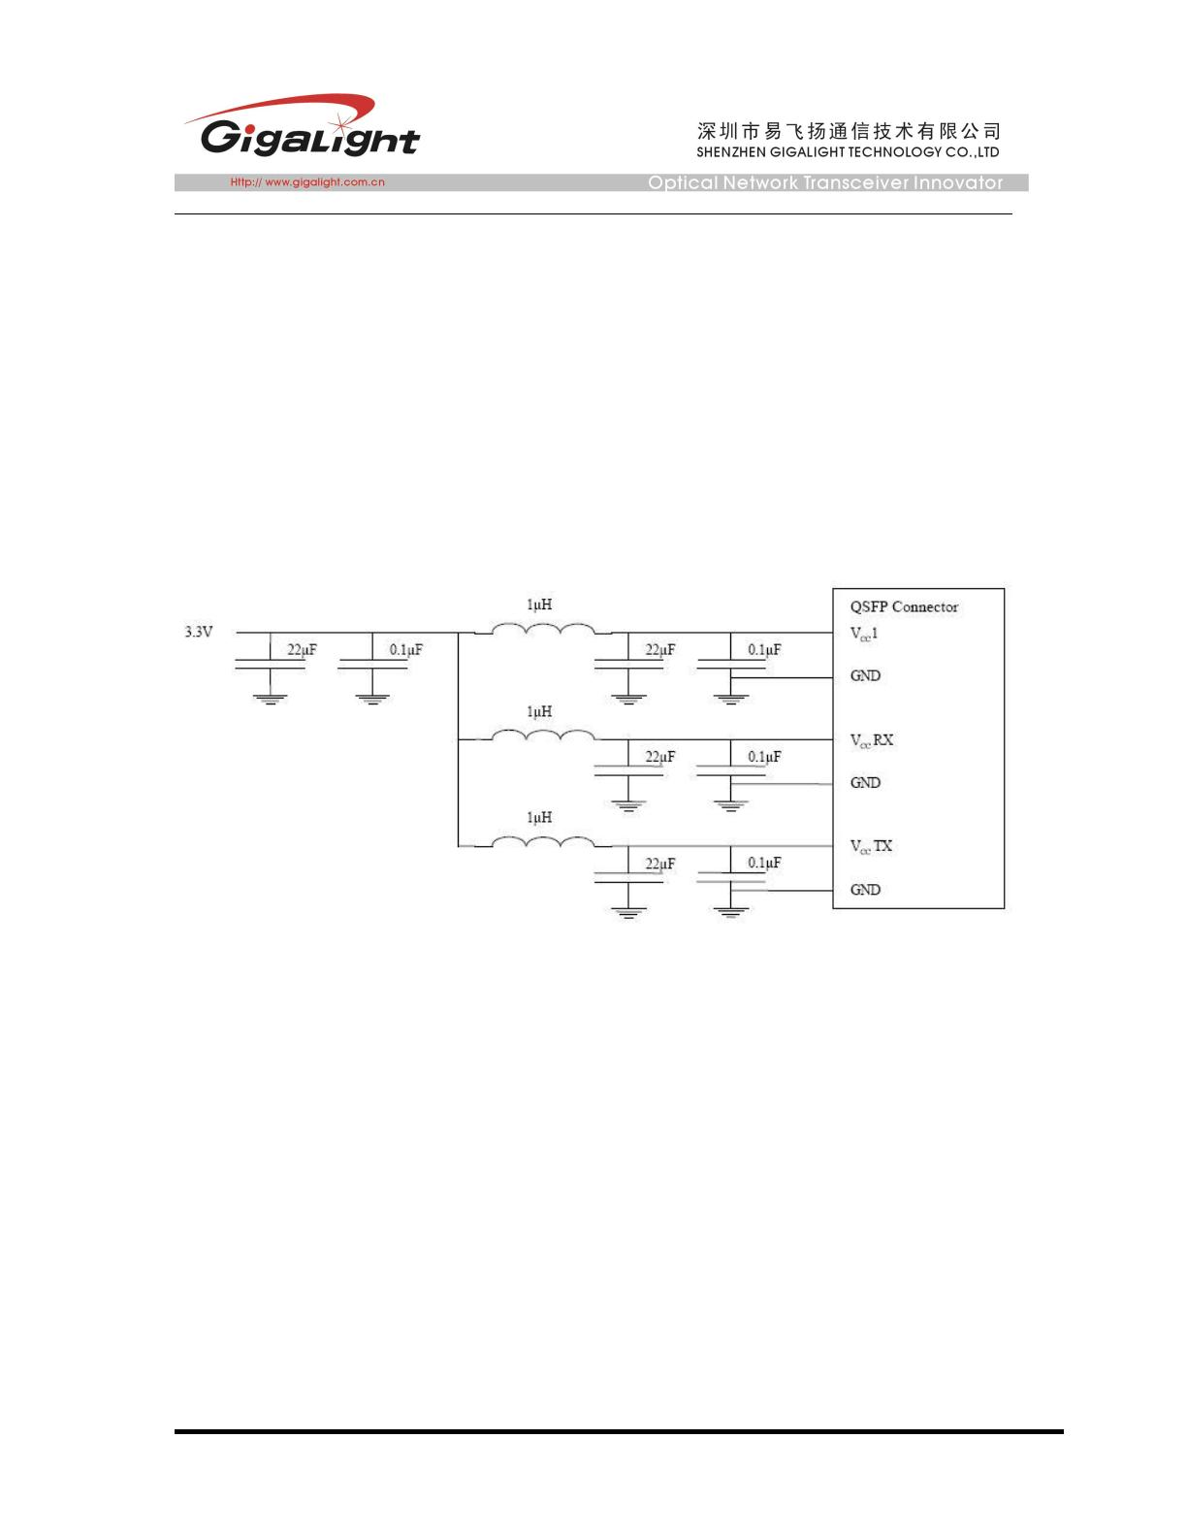

4x10GBASE-LR/W QSFP+ PSM LR4 10km Optical Interface
DIAGNOSTIC MONITORING INTERFACE
Digital diagnostics monitoring function is available on all Gigalight QSFP PSM AOCs. A
2-wire serial interface provides user to contact with module.
The structure of the memory is shown in Figure 4. The memory space is arranged into a
lower, single page, address space of 128 bytes and multiple upper address space pages.
This structure permits timely access to addresses in the lower page, such as Interrupt Flags
and Monitors. Less time critical time entries, such as serial ID information and threshold
settings, are available with the Page Select function.
The interface address used is A0xh and is mainly used for time critical data like interrupt
handling in order to enable a one-time-read for all data related to an interrupt situation. After
an interrupt, IntL, has been asserted, the host can read out the flag field to determine the
affected channel and type of flag.
Page 8 of 14
Aug 19 / 2016 V1
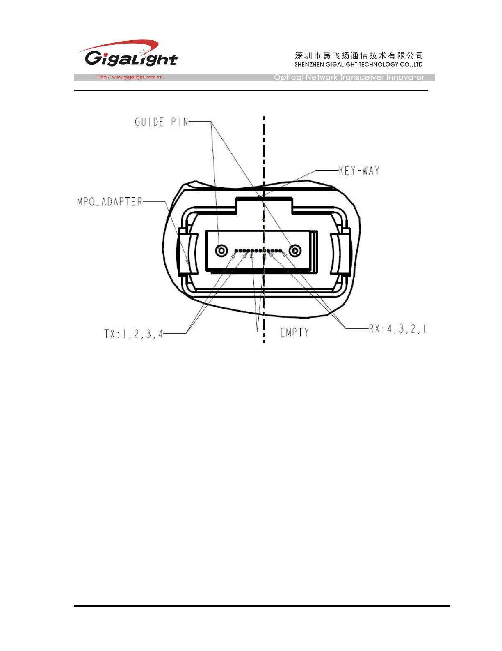

Figure4. QSFP Memory Map
Page 9 of 14
Aug 19 / 2016 V1
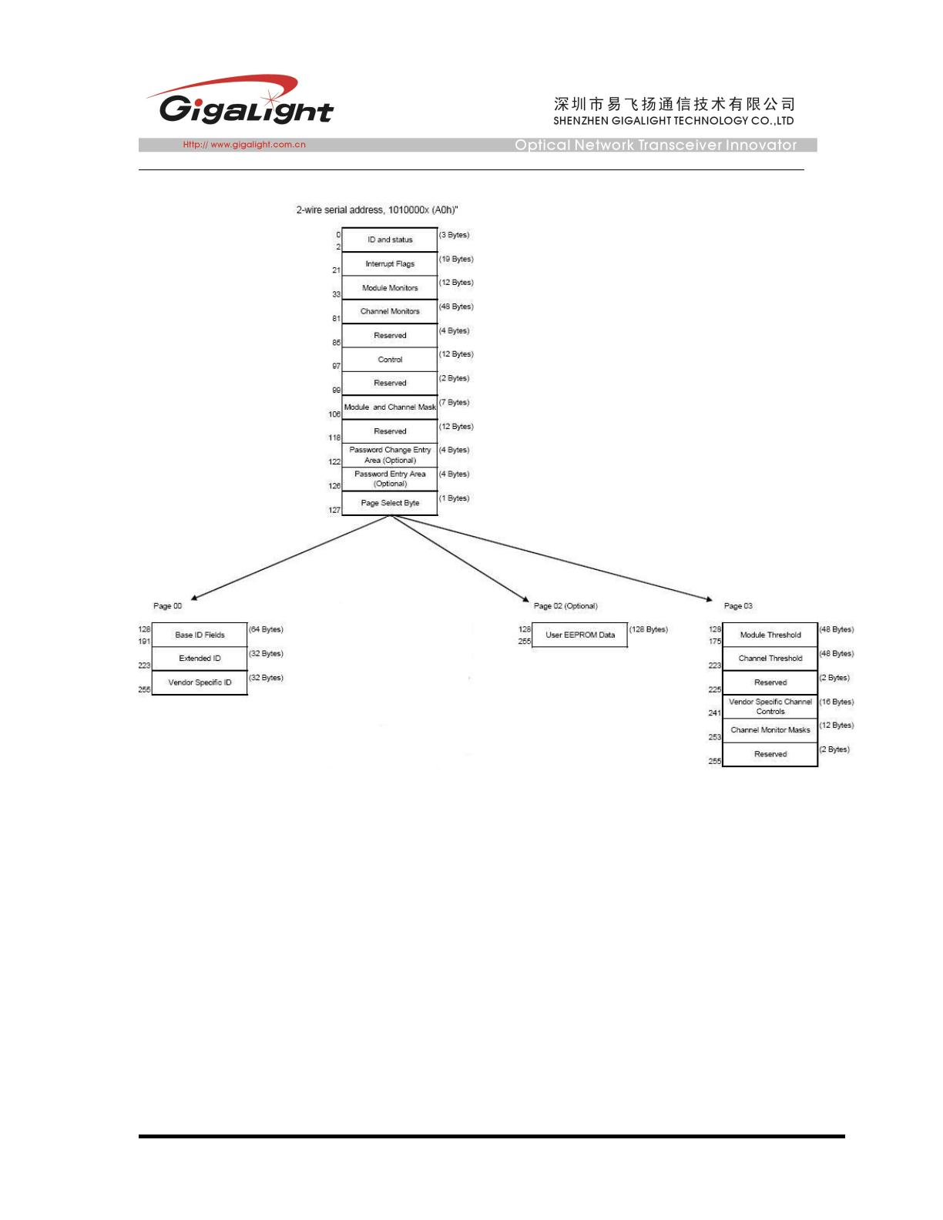

Figure5. Low Memory Map
Figure6. Page 03 Memory Map
Page 10 of 14
Aug 19 / 2016 V1
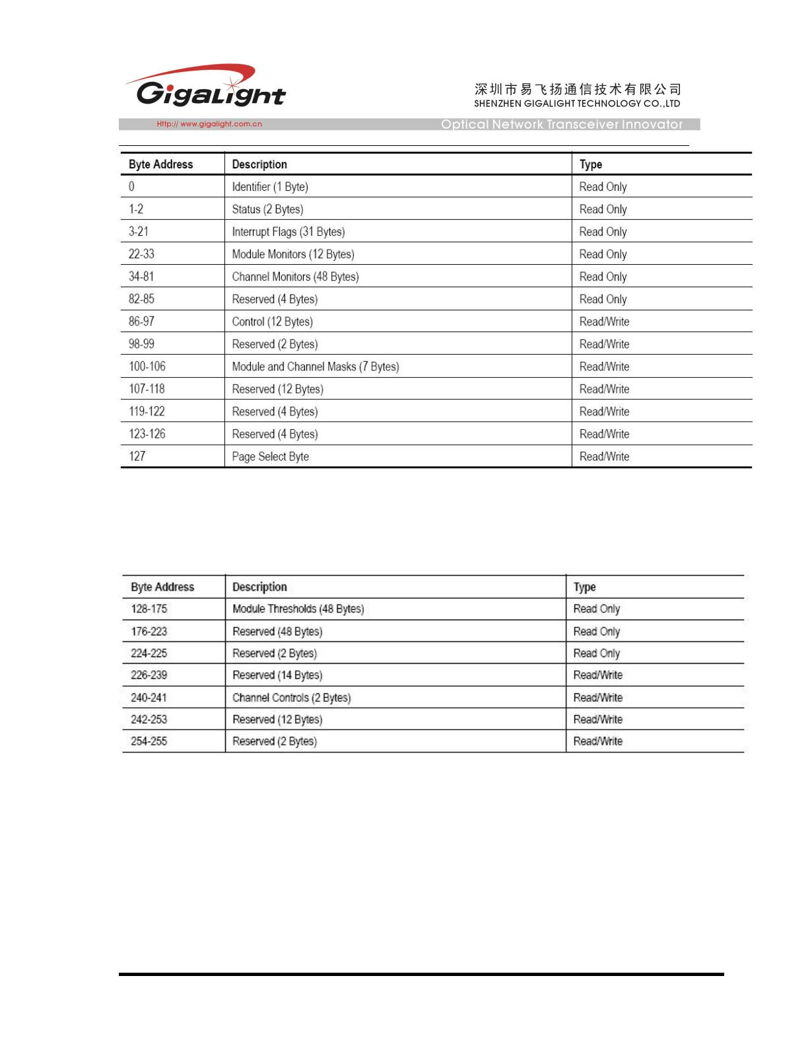

Figure7. Page 00 Memory Map
Page 11 of 14
Aug 19 / 2016 V1
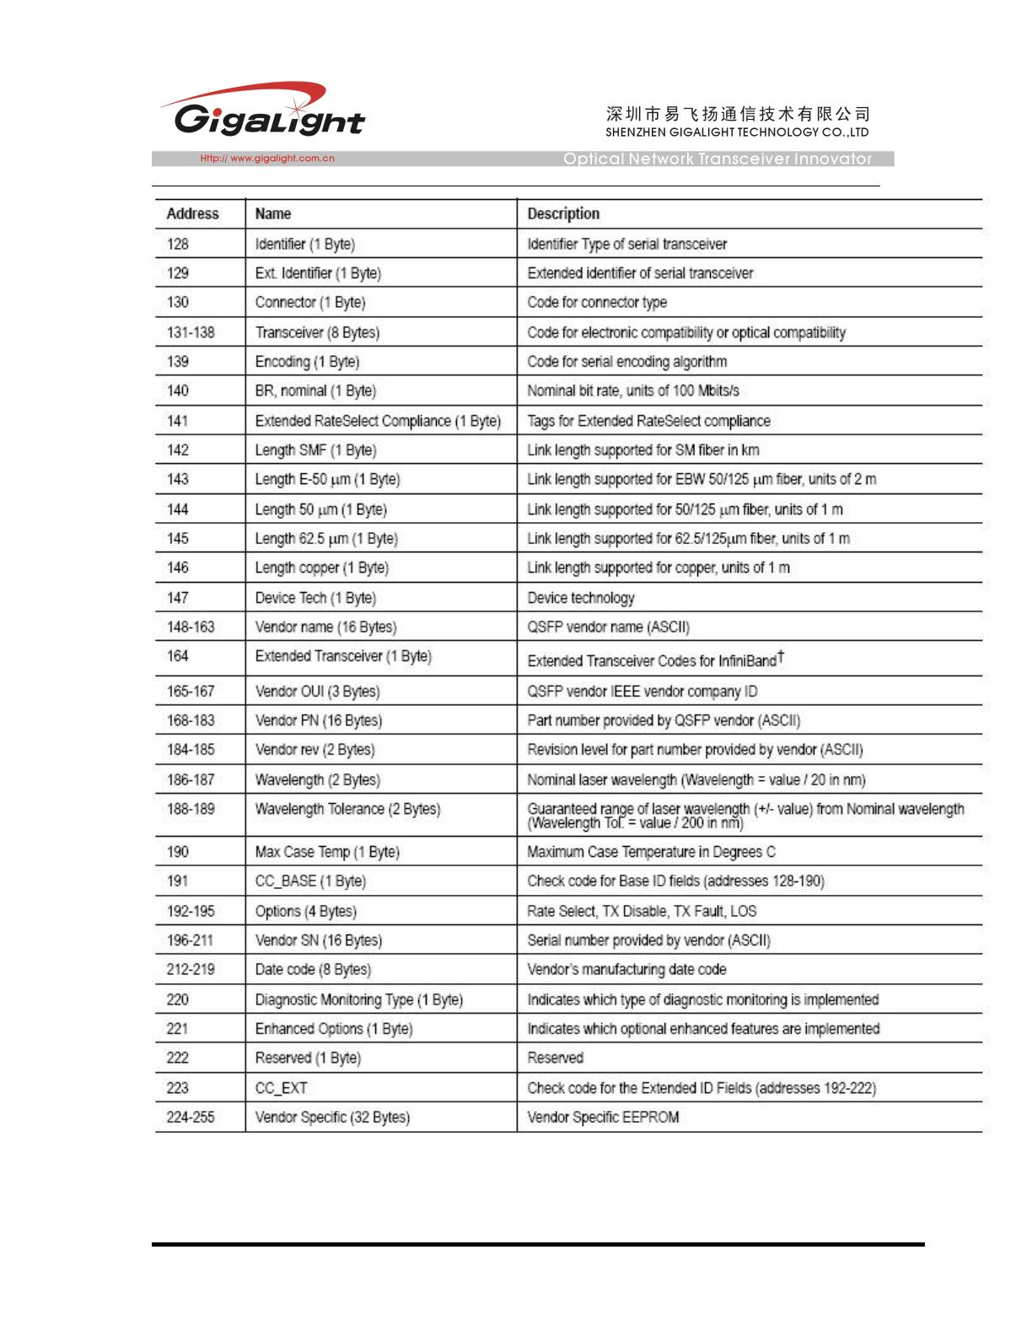

Page02 is User EEPROM and its format decided by user.
The detail description of low memory and page00.page03 upper memory please see
SFF-8436 document.
Timing for Soft Control and Status Functions
Parameter
Symbol
Max
Unit
Conditions
Time from power on
2
, hot plug or rising edge of
Initialization
Time
Reset until the module is fully functional This
3
time does not apply to non-Power Level 0
modules in the Low Power State
t_init
2000
ms
A Reset is generated by a low level longer than
the minimum reset pulse time present on the
ResetL pin.
Reset Init Assert
Time
t_reset_init
t_serial
2
μs
Serial Bus
Hardware
Ready Time
Monitor Data
Ready Time
Reset Assert
Time
Time from power on until module responds to
2
data transmission over the 2-wire serial bus
2000
ms
Time from power on to data not ready, bit 0 of
2
Byte 2, deasserted and IntL asserted
t_data
t_reset
2000
2000
ms
ms
Time from rising edge on the ResetL pin until the
module is fully functional
3
Time from assertion of LPMode (Vin:LPMode =
Vih) until module power consumption enters
lower Power Level 1
LPMode Assert
Time
ton_LPMode
Toff_LPMode
ton_IntL
100
300
200
μs
LPMode
Deassert
Time
Time
(Vin:LPMode=Vil)
functional3,5
for
deassertion
until
of
module
LPMode
ms
ms
is
fully
Time from occurrence of condition triggering IntL
until Vout:IntL = Vol
IntL Assert Time
Time from clear on read operation of associated
4
IntL Deassert
Time
toff_IntL
ton_los
500
100
200
μs
flag until Vout:IntL = Voh. This includes deassert
times for Rx LOS, Tx Fault and other flag bits.
Time from Rx LOS state to Rx LOS bit set
(value=1b) and IntL asserted
Rx LOS Assert
Time
ms
ms
Tx Fault Assert
Time
Time from Tx Fault state to Tx Fault bit set
(value=1b) and IntL asserted
ton_Txfault
Time from occurrence of condition triggering flag
to associated flag bit set (value=1b) and IntL
asserted
Flag Assert Time
ton_flag
200
ms
Mask Assert
Time
Time
associated IntL assertion is inhibited
from
mask
bit
set(value=1b)
1
until
ton_mask
toff_mask
100
100
ms
ms
Mask Deassert
Time
Time from mask bit cleared (value=0b)
1
associated IntlL operation resumes
until
Application or
Rate Select
Change Time
Time from change of state of Application or Rate
Select Bit until transmitter or receiver bandwidth
is in conformance with appropriate specification
t_ratesel
100
μs
1
Page 12 of 14
Aug 19 / 2016 V1
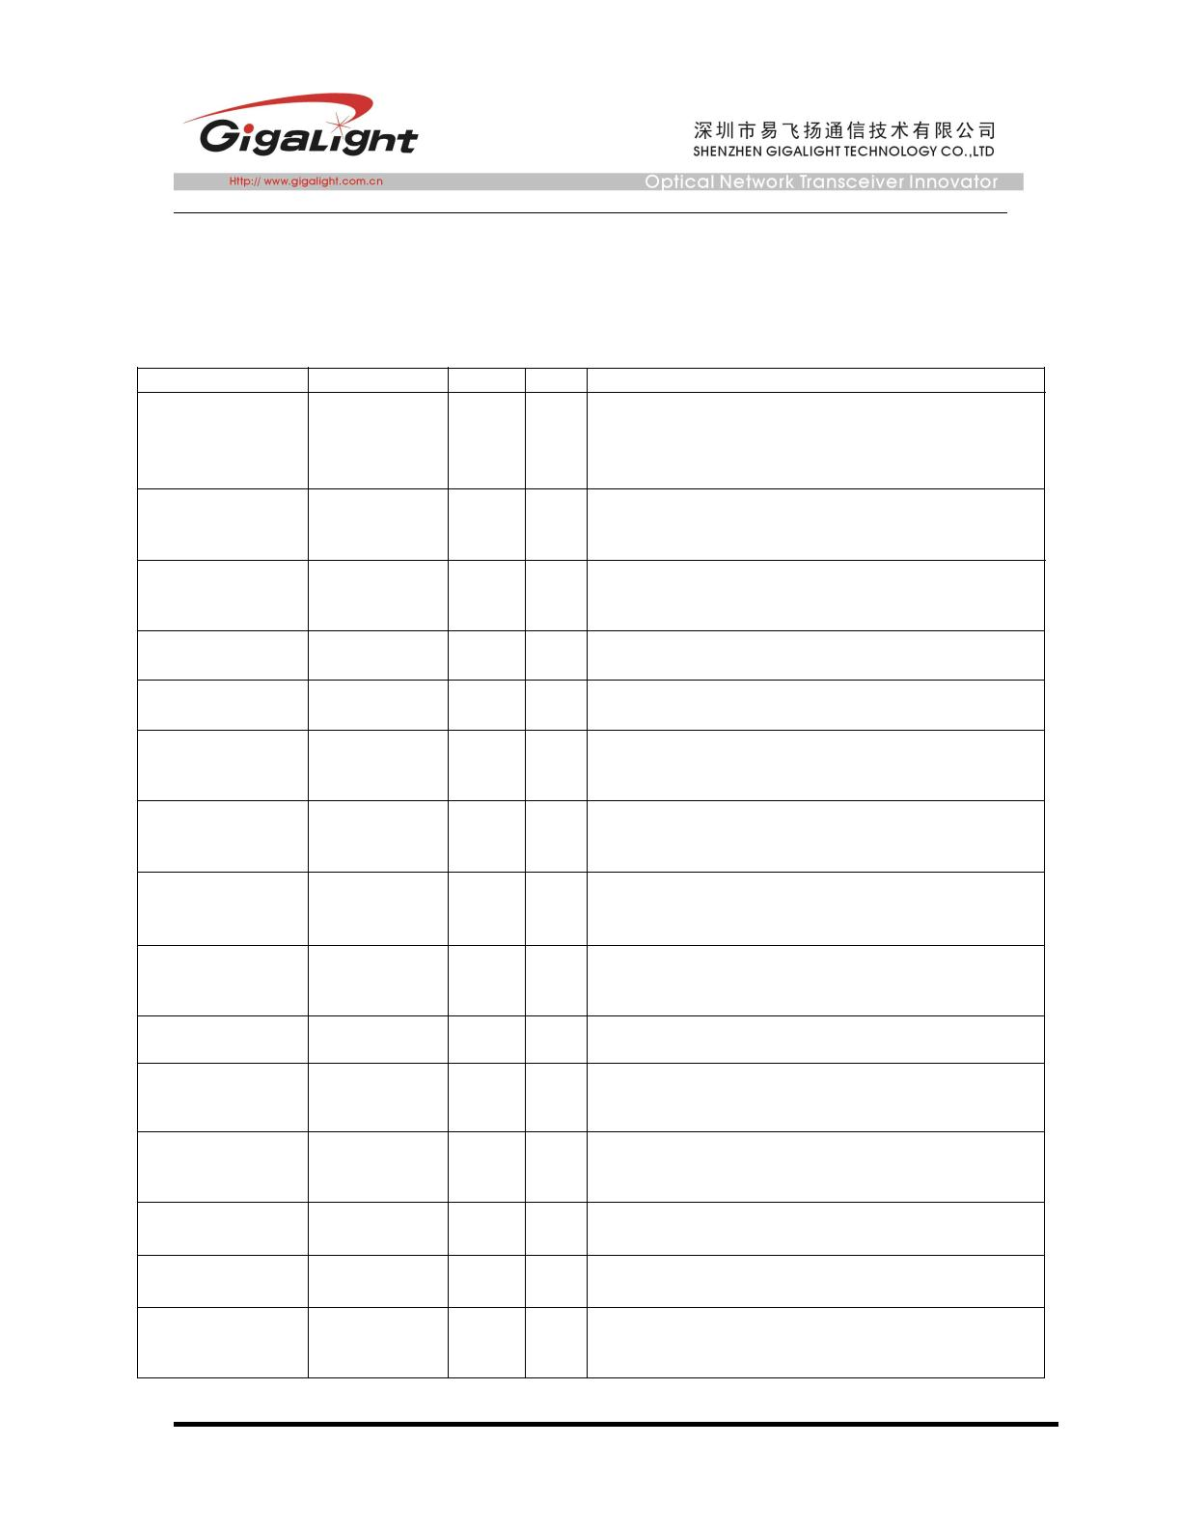

Power_over-ride
or Power-set
Assert Time
Power_over-ride
or Power-set
Deassert Time
Time from P_Down bit set (value=1b) until
1
module power consumption enters lower Power
Level 1
ton_Pdown
toff_Pdown
100
300
ms
ms
Time from P_Down bit cleared(value=0b) until
1
the module is fully functional
3
Note：
1. Power on is defined as the instant when supply voltages reach and remain at or above the minimum
specified value.
2. Fully functional is defined as IntL asserted due to data not ready bit, bit 0 byte 2 deasserted.
3. Measured from falling clock edge after stop bit of read transaction.
4. Measured from falling clock edge after stop bit of write transaction.
Mechanical Dimensions
Figure9. Mechanical Specifications
ESD
This QSFP PSM LR4 is specified as ESD threshold 1KV for high speed data pins and 2KV for
all others electrical input pins, tested per MIL-STD-883, Method 3015.4 /JESD22-A114-A
(HBM). However, normal ESD precautions are still required during the handling of this module.
This transceiver is shipped in ESD protective packaging. It should be removed from the
packaging and handled only in an ESD protected environment
Page 13 of 14
Aug 19 / 2016 V1
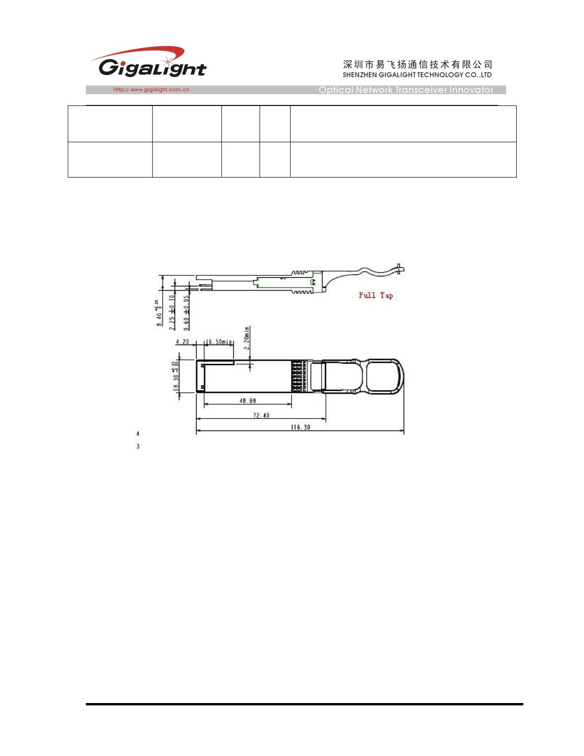

Female MPO Connector with 8-degree End-face for this module
Ordering information
Part Number
Product Description
GQM-SPO400-LR4CB
4x10GBASE-LR/W QSFP+ PSM LR4 up to 10km, MPO connector
Important Notice
Performance figures, data and any illustrative material provided in this data sheet are typical and must be
specifically confirmed in writing by GIGALIGHT before they become applicable to any particular order or
contract. In accordance with the GIGALIGHT policy of continuous improvement specifications may change
without notice.
The publication of information in this data sheet does not imply freedom from patent or other protective rights
of GIGALIGHT or others. Further details are available from any GIGALIGHT sales representative.
sales@gigalight.com.cn
http://www.gigalight.com.cn
Page 14 of 14
11/26/ 2014
